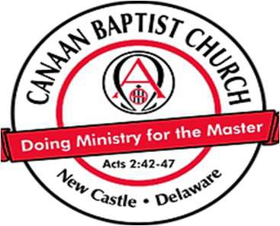
CANAAN BAPTIST CHURCH
Requisition / Reimbursement Request

PLEASE ALLOW ONE WEEK PROCESSING TIME FOR ALL REQUESTS

FROM: DATE:

DATE NEEDED:
CHECK TO BE MAILED: YES  (Include mailing address)
CHECK TO BE MAILED: NO (All checks can be picked up from the church office during normal operating
hours: Tuesday - Friday 9:00 am - 1:00 pm or Sunday after church.) PURPOSE:
PAY TO THE ORDER OF:

ADDRESS:

REIMBURSEMENT AMOUNT: $ (Original receipts must be attached and itemized below)

ADVANCE CHECK AMOUNT: $
Requests for reimbursement must be submitted within 60 days after the event.

RETURNING FUNDS: $

Ministry | Date | Description | Amount

Ministry Leader’s Approval:

TRUSTEE USE ONLY

AUTHORIZED BY:

ACCOUNT : CHECK #: DATE:

REVISED: 03/01/2025

